ID_3 Toolkit Script Examples Companion

APOD-ID3-SCRIPT-EXAMPLES-001
Document Control Information
Document Identifier: APOD-ID3-SCRIPT-EXAMPLES-001
Title: Access-Mode ID_3 – Operator / Inspection & Freeze Discipline
Toolkit Script Examples Companion
Edition: Companion Handbook — Version ID_3
Date of Issue: 1st March 2026
Status: Informative Companion — Non-Normative
Author: Anthony Siljeg
Affiliation: Alnotrea Labs / Policy of Developments — Access PoD Initiative

Contents
1. Toolkit Introduction 2
2. Full Script List (Execution Index) 3
3. Folder Transition Model 5
4. Environment Requirements 6
5. Execute Inspection Cycle (Example: 2026-02-10) 8
Executing commands in PowerShell 7: 8
6. Post-Freeze Review Pack Reset (Critical) 15
7. Validation Checklist 16
8. Recovery / Rollback Model 17
9. Execution Model Summary 17

1. Toolkit Introduction
The Access-Mode ID_3 Toolkit provides the execution layer for ID_3 inspection, correction, canonical promotion, freeze declaration, and integrity anchoring.
This document is procedural and execution-focused.
It operationalizes the structural discipline defined in:
- Access-Mode ID_3 — Operator / Inspection & Freeze Discipline
- Rule Engine Formalization — APOD-ID3-RULE-001
ID_3 execution is designed to be lightweight once session material is prepared.
A typical inspection cycle takes approximately 15 minutes (excluding reading/review time).
The toolkit enforces a deterministic transition model:
ID_2 session artifacts
↓
ID_3 intake (ID_2_inbox\<DATE>)
↓
Working pack (10_working → 20_corrected)
↓
Canonical promotion
↓
Freeze declaration
↓
Integrity anchor (hashes.txt)
↓
ID_3_outbox
↓
Review pack reset
The final stage ensures:
- The working review folder (e.g., 2026-02-10\ID3-20260210-module03-timepressure) is no longer needed.
- The ID_3 review date folder (e.g., 2026-02-10) can be removed once empty.
- The ID_2_inbox date folder is moved to records_only for governance archive.
- The root workspace ID_3_review_packs\ is clean and ready for the next inspection cycle.
The scripts are structured to support this clean-cycle discipline.
ID_3 inspection is repeatable, not cumulative.
Each run:
- Produces a new immutable outbox pack.
- Preserves provenance.
- Cleans the working space.

2. Full Script List (Execution Index)
The following scripts form the ID_3 execution pipeline.

2.1 Inspect-SessionMetadataShapes.ps1
Purpose:
Performs structural diagnostics on baseline and variant session artifacts.
Stage:
Initial verification (10_working surface).
Function:
- Detects required field presence.
- Validates timestamp formats.
- Detects placeholder identifiers.
- Produces completeness scoring (diagnostic only).
- Identifies schema shape inconsistencies.
Output:
- Structural diagnostic report.
- No file modification.
This script determines whether correction is required.

2.2 Correct-ID3SessionMetadata.ps1
Purpose:
Applies metadata-only structural normalization.
Stage:
Correction phase (20_corrected surface).
Permitted Corrections:
- Deterministic placeholder ID replacement.
- Timestamp normalization to ISO 8601 UTC.
- Array coercion (scalar → array).
- Structural ordering normalization.
Not Permitted:
- Semantic inference.
- Reasoning modification.
- Sign-off reconstruction.
- Content fabrication.
Output:
- Corrected artifacts in 20_corrected.
- Logged structural alignment actions.

2.3 Inspect-SessionMetadataShapes.ps1 (Re-Run)
Purpose:
Re-verifies corrected artifacts.
Stage:
Re-verification.
Condition:
- Zero required-field failures.
- No non-fabrication violations.
Promotion eligibility must be confirmed before freeze.

2.4 Move-And-Freeze-ID3Outbox.ps1
Purpose:
Canonical promotion, freeze declaration, and integrity anchoring.
Stage:
Promotion → Freeze → Hash.
Modes:
DryRun:
- Simulates freeze and promotion.
- Confirms expected output structure.
Real Run:
- Generates canonical JSON artifacts.
- Applies inspection metadata.
- Declares freeze.
- Generates hashes.txt.
- Moves pack to ID_3_outbox.
Outputs:
- session_baseline.canonical.json
- session_variant.canonical.json
- module_03_baseline.canonical.json
- module_03_variant.canonical.json
- hashes.txt
- Immutable outbox pack

3. Folder Transition Model
During execution, files move through structured stages:

Stage 1 — Intake
ID_3_review_packs\
ID_2_inbox\<DATE>\
Source of ID_2 session artifacts.

Stage 2 — Working Pack
ID_3_review_packs\<DATE>\ID3-<DATE>-<label>\
10_working\
20_corrected\
Temporary inspection surface.
This folder is a transient workspace.

Stage 3 — Freeze Output
ID_3_review_packs\ID_3_outbox\
Contains immutable frozen packs.

Stage 4 — Governance Archive
ID_3_review_packs\records_only\
Contains historical ID_2 inbox sessions used for inspection.

Stage 5 — Workspace Reset
After successful freeze:
- Confirm outbox pack exists.
- Move ID_2_inbox\<DATE> → records_only\.
- Delete empty review date folder (e.g., 2026-02-10).
- Confirm ID_3_review_packs\ root contains only:
  - ID_3_outbox
  - records_only
  - ID_2_inbox (ready for next intake)
This reset ensures:
- No residue from prior inspection cycles.
- Deterministic environment.
- Clean starting point for next run.

4. Environment Requirements
ID_3 execution assumes the following environment:

Software
- PowerShell 7+
- Access-Mode ID_3 operator scripts installed under:
C:\v1.0-Access-mode\modes\ID_3_operator\

Required Structure
ID_3_review_packs\
ID_2_inbox\
ID_3_outbox\
records_only\

Rule Specification
The following file must exist:
scripts\rules\session_completeness.rule.json
Rule version must match the intended inspection cycle.
The following steps below complete the freeze cycle.

5. Execute Inspection Cycle (Example: 2026-02-10)

Executing commands in PowerShell 7:
This section defines the complete ID_3 cycle. If using the standalone ID_3 release with pre-populated ID_2 inbox artifacts, Step 1 may be skipped.
C:\v1.0-Access-mode\modes\ID_3_operator\ID_3_review_packs\ID_2_inbox\2026-02-10
Note 1: For other sessions (custom) from ID_2 standalone release adjust the path folder (DATE) YYYY-MM-DD from C:\v1.0-Access-mode\modes\ID_2_access\records\sessions\YYYY-MM-DD.
Note 2: If both releases are on disc C:\v1.0-Access-mode\modes\ID_2_access & ID_3_operator use step 1 and proceed with all steps.
TIP: If ID_2_access is used and a session is complete move ID_3_operator under C:\v1.0-Access-mode\modes\ - All modes ID_x are required on disc in \modes\ folder. Then proceed to step 1.
Total time (excluding session review): ~15 minutes

STEP 1 — Intake Copy (ID_2 → ID_3 Inbox)
Purpose: Create deterministic intake surface.
All steps below are executed from:
cd “C:\v1.0-Access-mode\modes\ID_3_operator”
--- All commands below are intended for direct copy/paste execution in PowerShell 7.
pwsh -NoProfile -Command "New-Item -ItemType Directory -Force -Path 'C:\v1.0-Access-mode\modes\ID_3_operator\ID_3_review_packs\ID_2_inbox\2026-02-10' | Out-Null"
pwsh -NoProfile -Command "robocopy 'C:\v1.0-Access-mode\modes\ID_2_access\records\sessions\2026-02-10' 'C:\v1.0-Access-mode\modes\ID_3_operator\ID_3_review_packs\ID_2_inbox\2026-02-10' /E /NFL /NDL /NJH /NJS /NC /NS /NP /R:1 /W:1 | Out-Null"
--- Replace YYYY-MM-DD and session folder names as required for custom runs.
Guardrail:
Do NOT use /MIR.

STEP 2 — Create 10_working Surface (Deterministic Copy)
Purpose
Extract only the required inspection artifacts from the ID_2 inbox:
- session.json
- module_03_sapp_simulation_stress_testing_ID_2.json
From Step 1:
ID_3_review_packs\ID_2_inbox\2026-02-10\
Into – Step 2:
ID_3_review_packs\2026-02-10\ID3-20260210-module03-timepressure\10_working\
This is a strict extraction step.
No correction (STEP 4) occurs here yet.

Proceed to the next page - step 2.

Deterministic Copy Block “# STEP 2 to Length” below.

--- Execute the following commands in PowerShell 7:
# STEP 2 — Create 10_working structure and copy required artifacts
$in = "C:\v1.0-Access-mode\modes\ID_3_operator\ID_3_review_packs\ID_2_inbox\2026-02-10"
$out = "C:\v1.0-Access-mode\modes\ID_3_operator\ID_3_review_packs\2026-02-10\ID3-20260210-module03-timepressure\10_working"
# Ensure destination structure exists
New-Item -ItemType Directory -Force -Path `
(Join-Path $out "baseline\jsons"), `
(Join-Path $out "variants\jsons") | Out-Null
# Define deterministic source paths
$baselineSession = Join-Path $in "baseline\ID2-20260210-1835-session\artifacts\session.json"
$baselineModule03 = Join-Path $in "baseline\ID2-20260210-1835-session\artifacts\module_03_sapp_simulation_stress_testing_ID_2.json"
$variantSession = Join-Path $in "variants\ID2-20260210-1907-session-timepressure\artifacts\session.json"
$variantModule03 = Join-Path $in "variants\ID2-20260210-1907-session-timepressure\artifacts\module_03_sapp_simulation_stress_testing_ID_2.json"
# Fail fast if any required source file is missing
foreach ($src in @($baselineSession,$baselineModule03,$variantSession,$variantModule03)) {
if (-not (Test-Path -LiteralPath $src)) {
throw "Missing required source file: $src"
}
}
# Copy baseline
Copy-Item -LiteralPath $baselineSession -Destination (Join-Path $out "baseline\jsons\session.json") -Force
Copy-Item -LiteralPath $baselineModule03 -Destination (Join-Path $out "baseline\jsons\module_03_sapp_simulation_stress_testing_ID_2.json") -Force
# Copy variant
Copy-Item -LiteralPath $variantSession -Destination (Join-Path $out "variants\jsons\session.json") -Force
Copy-Item -LiteralPath $variantModule03 -Destination (Join-Path $out "variants\jsons\module_03_sapp_simulation_stress_testing_ID_2.json") -Force
# Verification (should output exactly 4 files)
Get-ChildItem $out -Recurse -File | Select-Object FullName, Length

--- Replace YYYY-MM-DD and session folder names as required for custom runs.

Expected Output
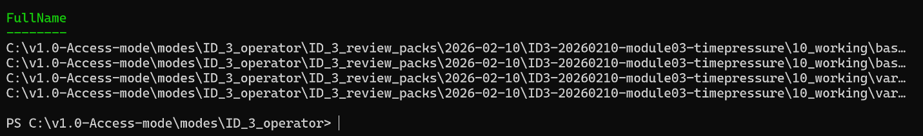
On disc you should see exactly 4 files in working_10 folder:
baseline\jsons\session.json
baseline\jsons\module_03_sapp_simulation_stress_testing_ID_2.json
variants\jsons\session.json
variants\jsons\module_03_sapp_simulation_stress_testing_ID_2.json

or verify on PS7 console right after step 2:

Get-ChildItem $out -Recurse -File

STEP 3 — Inspect

From - C:\v1.0-Access-mode\modes\ID_3_operator\

--- Execute the following commands in PowerShell 7:
.\scripts\Inspect-SessionMetadataShapes.ps1

Expected Output
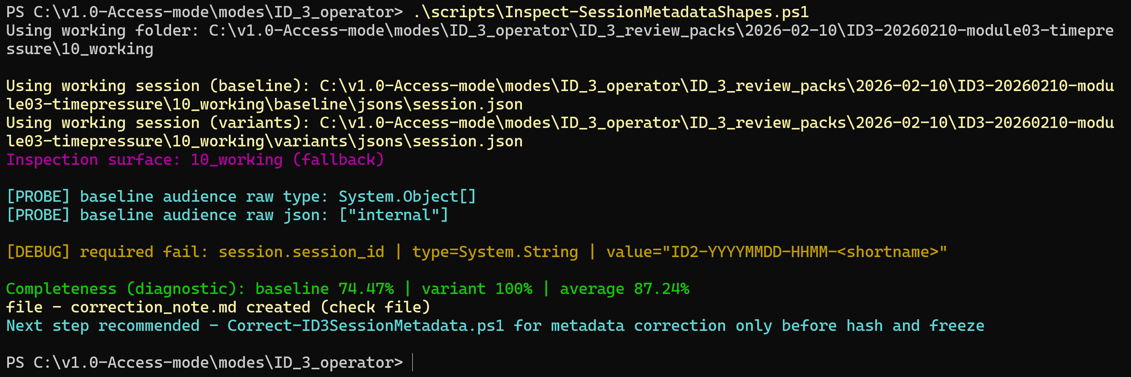
Confirm that correction_note.md exists in the 20_corrected folder:
C:\v1.0-Access-mode\modes\ID_3_operator\ID_3_review_packs\2026-02-10\ID3-20260210-module03-timepressure\20_corrected
- Required constraints pass or are correctable
- No non-fabrication violations

STEP 4 — Correct

--- Execute the following commands in PowerShell 7:
.\scripts\Correct-ID3SessionMetadata.ps1
Corrections are metadata-only.
Expected Output
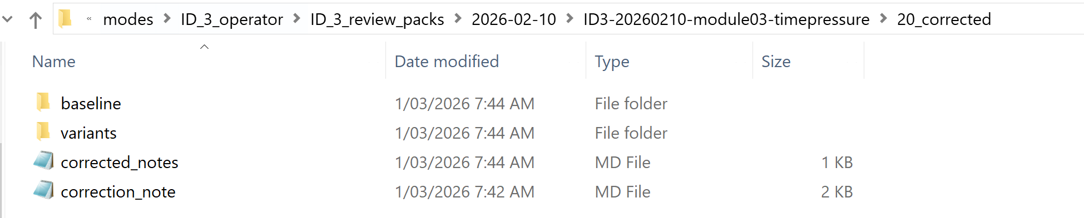
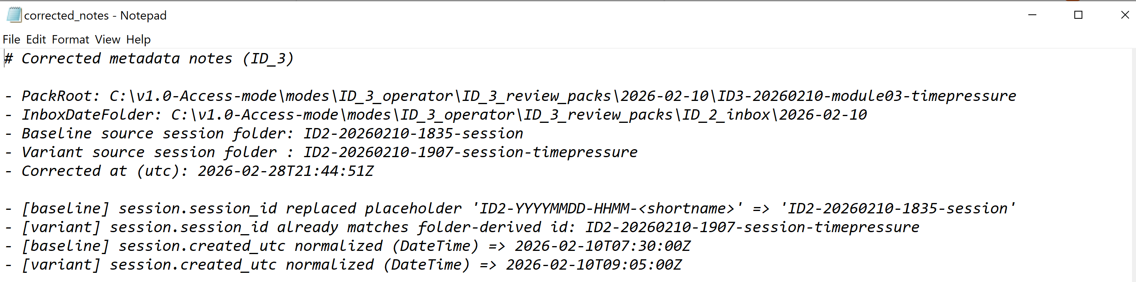
Confirm that corrected_notes.md exists in the 20_corrected folder:
C:\v1.0-Access-mode\modes\ID_3_operator\ID_3_review_packs\2026-02-10\ID3-20260210-module03-timepressure\20_corrected

STEP 5 — Re-Inspect
--- Execute the following commands in PowerShell 7:

.\scripts\Inspect-SessionMetadataShapes.ps1
Required failures must equal zero (from ID_2 session to ID_3 inspect - steps 3 to step 5) before freeze.
Expected Output
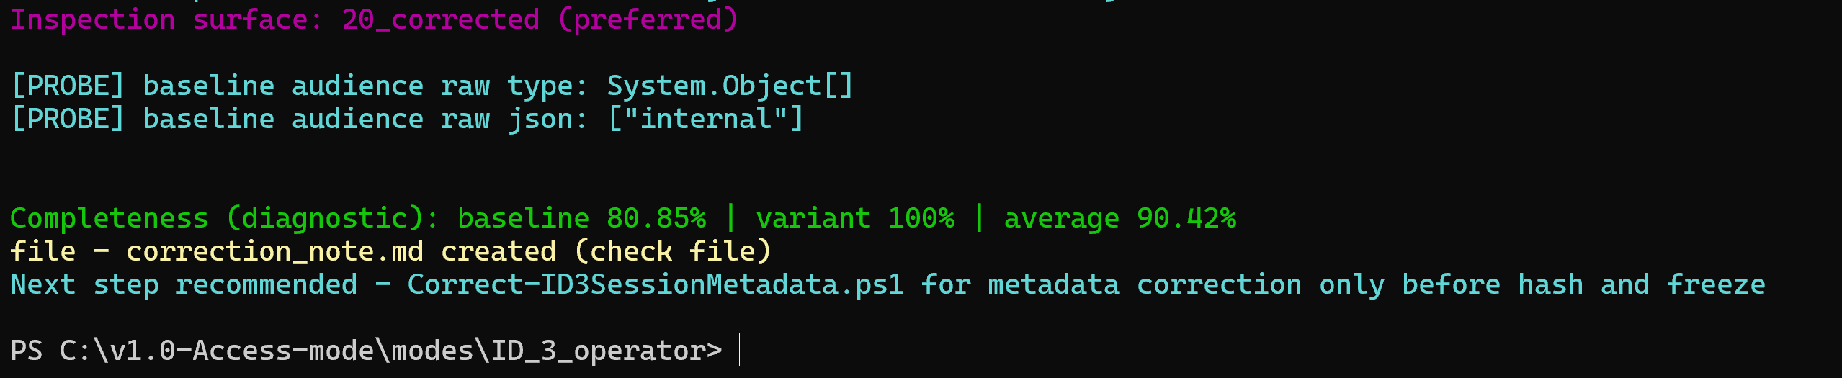
Confirm that updated correction_note.md exists in the 20_corrected folder:
C:\v1.0-Access-mode\modes\ID_3_operator\ID_3_review_packs\2026-02-10\ID3-20260210-module03-timepressure\20_corrected
NOTE: The current working space (FOLDERS) steps 2 to step 5 will convert to a freeze/hash package after step 7.

STEP 6 — Freeze (Dry Run optional) recommended.

--- Execute the following commands in PowerShell 7:
pwsh .\scripts\Move-And-Freeze-ID3Outbox.ps1 `
-PackRoot "C:\v1.0-Access-mode\modes\ID_3_operator\ID_3_review_packs\2026-02-10\ID3-20260210-module03-timepressure" `
-OutboxRoot "C:\v1.0-Access-mode\modes\ID_3_operator\ID_3_review_packs\ID_3_outbox" `
-InboxRoot "C:\v1.0-Access-mode\modes\ID_3_operator\ID_3_review_packs\ID_2_inbox" `
-DryRun
Confirm expected canonical files on PS7 console view only.

Proceed to real run on next page.

STEP 7 — Freeze (Real Run)

--- Execute the following commands in PowerShell 7:
pwsh .\scripts\Move-And-Freeze-ID3Outbox.ps1 `
-PackRoot "C:\v1.0-Access-mode\modes\ID_3_operator\ID_3_review_packs\2026-02-10\ID3-20260210-module03-timepressure" `
-OutboxRoot "C:\v1.0-Access-mode\modes\ID_3_operator\ID_3_review_packs\ID_3_outbox" `
-InboxRoot "C:\v1.0-Access-mode\modes\ID_3_operator\ID_3_review_packs\ID_2_inbox"
Expected Output
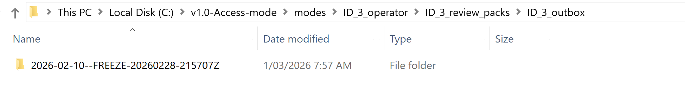
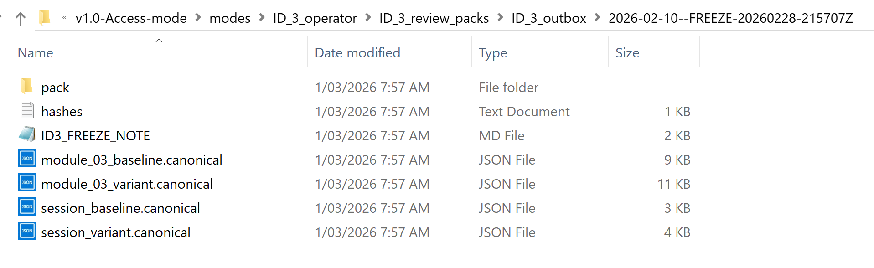
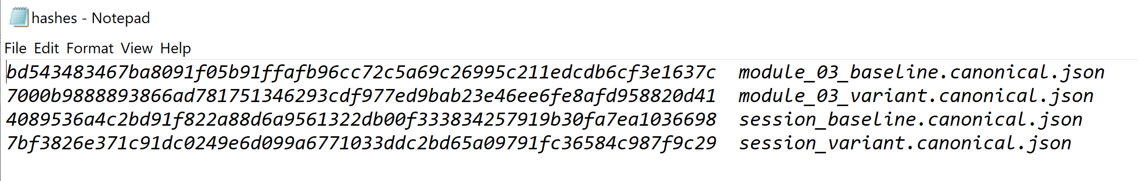
Confirm freeze and hash package with:
--- Execute the following commands in PowerShell 7:
Get-ChildItem "C:\v1.0-Access-mode\modes\ID_3_operator\ID_3_review_packs\ID_3_outbox"
The canonical pack must exist and contain hashes.txt. Confirm the timestamped folder and ID_3_Freeze_Note.md are present.
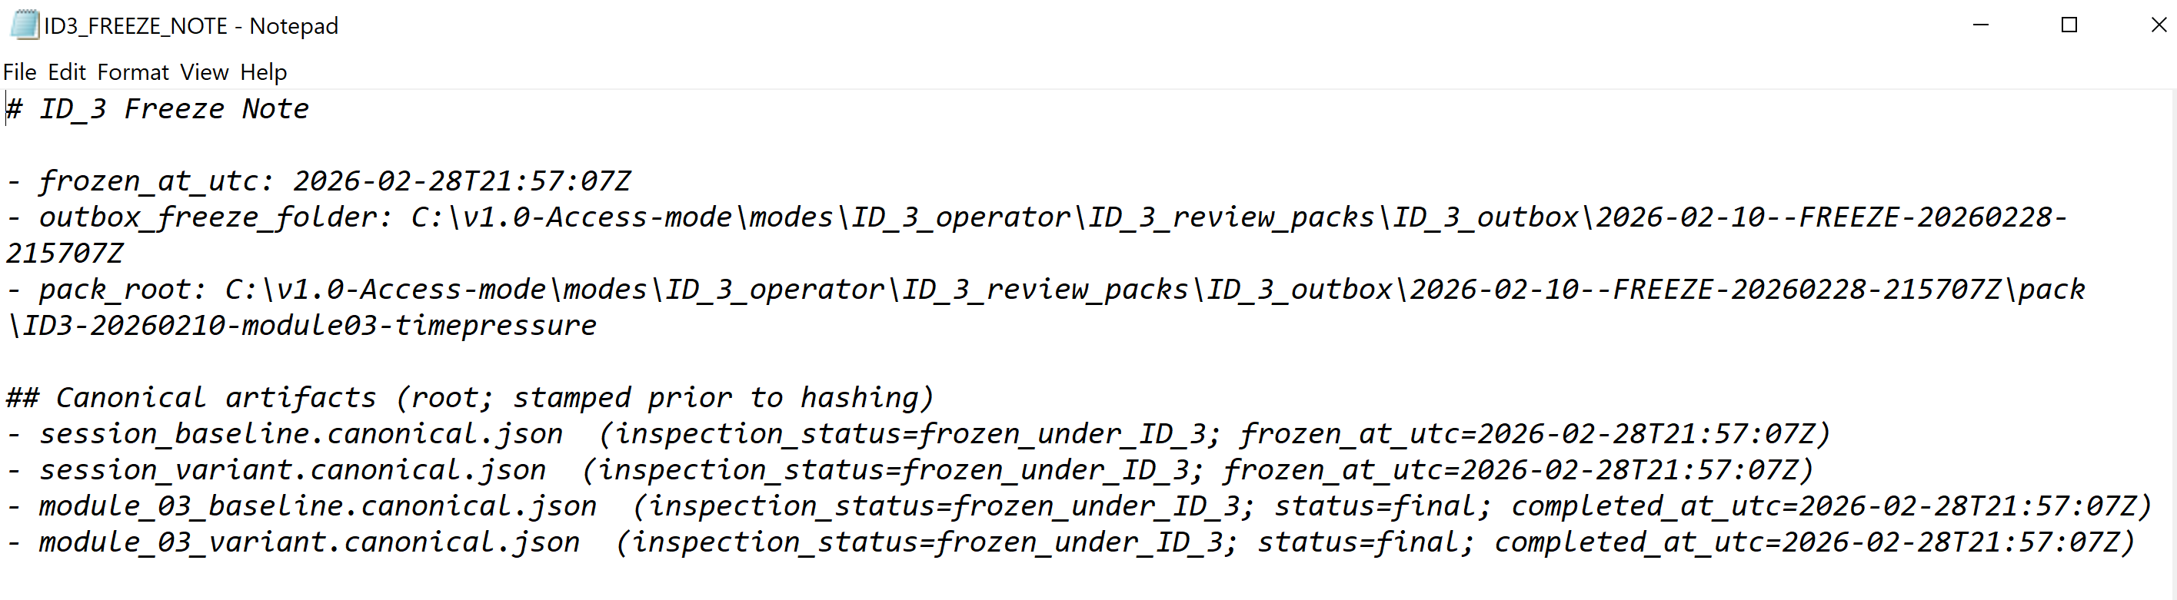

6. Post-Freeze Review Pack Reset (Critical)
These next two steps ensure the toolkit remains repeatable and deterministic using the same procedure outlined in Steps 1 through 7.
6.1 Move Inbox to Governance Records

This step preserves ID_2 provenance as governance record.

--- Execute the following commands in PowerShell 7:
$src = "C:\v1.0-Access-mode\modes\ID_3_operator\ID_3_review_packs\ID_2_inbox\2026-02-10"
$dst = "C:\v1.0-Access-mode\modes\ID_3_operator\ID_3_review_packs\records_only\2026-02-10"

if (Test-Path $dst) {
throw "Archive already exists at records_only\2026-02-10 — manual review required."
}

Move-Item -LiteralPath $src -Destination $dst

---

6.2 Delete Empty Review Date Folder
If folder is empty:

--- Execute the following commands in PowerShell 7:
$reviewRoot = "C:\v1.0-Access-mode\modes\ID_3_operator\ID_3_review_packs\2026-02-10"

if ((Get-ChildItem $reviewRoot -Recurse -Force | Measure-Object).Count -eq 0) {
Remove-Item $reviewRoot -Force
}
---
Delete only after confirming the canonical pack exists in ID_3_outbox and the review date folder is empty.

6.3 Confirm Clean Root (Important)
Get-ChildItem `
"C:\v1.0-Access-mode\modes\ID_3_operator\ID_3_review_packs"
Expected:
ID_3_outbox\ (freeze/hash - ready for seal and long-term archive in v1.1-workspace release)
records_only\ (from original ID_2 provenance)
ID_2_inbox\ (clean and ready for next run)

7. Validation Checklist
Before ending cycle, confirm:
☐ Required constraints passed
☐ No non-fabrication violations
☐ Canonical artifacts generated
☐ hashes.txt present
☐ Outbox pack created
☐ Inbox moved to records_only
☐ Working review folder removed
☐ Root workspace clean

8. Recovery / Rollback Model
If freeze fails:
- Do NOT manually edit canonical artifacts.
- Review diagnostic output
- Correct metadata
- Re-run Inspect → Correct → Inspect
- Re-run Freeze (DryRun first)
If hash mismatch occurs:
- Verify deterministic ordering
- Verify timestamp normalization
- Re-run canonical promotion
If semantic inconsistency detected:
- Revert to ID_2 posture
- Do not attempt repair under ID_3

9. Execution Model Summary
ID_2
↓
Intake (STEP 1)
↓
10_working → 20_corrected (STEPS 2–4)
↓
Canonical Promotion (STEP 5)
↓
Freeze + Hash (STEP 6–7)
↓
Outbox → Archive → Reset

